H.T No
Regulations:
A15


Sreenidhi Institute of Science and Technology
(An Autonomous Institution)
Code No: 5B730 Date: 22-Nov-2018 (FN)

B.Tech IV-Year I-Semester End External Examination, November - 2018 (Regular)
Finite Element Method (ME)

Time: 3 Hours Max.Marks:75

Note: a) No additional answer sheets will be provided.
b) All sub-parts of a question must be answered at one place only, otherwise it will not be valued.
c) Missing data can be assumed suitably.

Part - A Max.Marks:25

Answer all QUESTIONS.

1. | Discuss the history of development of Finite element method. | [3M]
2. | Write the transformation matrix in truss members to convert local and global displacement vectors. | [3M]
3. | What is meant by iso-parametric representation? | [3M]
4. | Sketch the shape functions for a two dimensional four node quadrilateral element. | [3M]
5. | List the boundary conditions of steady state one dimensional conduction heat transfer problems | [3M]
6. | List some FEA software packages. | [2M]
7. | Discuss the load vector for uniformly distributed load on beam element. | [2M]
8. | Write the strain displacement relations in axi-symmetric solid element. | [2M]
9. | Write the load vector due to convection at the boundary in one dimensional heat transfer | [2M]
10. | Differentiate dynamic and static analyses. | [2M]
Part – B Max.Marks:50
ANSWER ANY FIVE QUESTIONS. EACH QUESTION CARRIES 10 MARKS.

11. |  | Axial load P = 300 KN is applied at 20° C to the rod as shown in Fig.1. The temperature is then raised to 60° C. The coefficient of thermal expansion for Aluminum is 23x10⁻⁶ per °C and Steel is 11.7x10⁻⁶ per °C. A_{Al} = 900 mm² , A_{Steel} = 1200 mm² , E_{Al} = 70 x 10⁹ N/m² , E_{Steel} = 200 x 10⁹ N/m² . Using FEM, Determine  i) the nodal displacement and  ii) element stresses and the reaction forces at the supports.  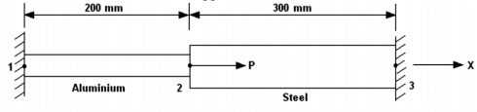  Fig.1 | [10M]
12. |  | For the two-bar truss shown in Fig.2, A force of P =1000 kN is applied at node 1 in the positive y direction while node 1 settles an amount δ = 50 mm in the negative x direction. Let E = 210 GPa and A = 6.00 x 10⁻⁴ m² for each element. The lengths of the elements are shown in the figure.  determine i) the displacement in the y direction of node 1 and  ii) the axial force in each element.  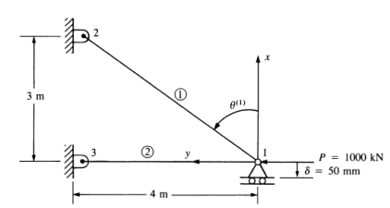  Fig.2 | [10M]
13. |  | The co-ordinates of an axi-symmetric element in mm are shown in Fig.3. Evaluate  i. Jacobian matrix. ii. Strain-displacement matrix.  z  3(30,40)  1(20,20) 2(40,20)  Fig.3 r | [10M]
14. |  | For the iso-parametric quadrilateral element shown in Fig.4, with the Cartesian co-ordinates.in cm. Evaluate  i).Shape functions. ii). Jacobian matrix.  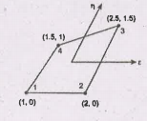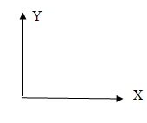  Fig-4 | [10M]
15. |  | Derive the finite element equations for steady state one dimensional fin problem by using Galerkin’s method. | [10M]
16. |  | Determine the eigen values of a stepped bar shown in Fig.5,  A₁=100 mm²  A₂=40 mm²  400m Fig.5 800mm | [10M]
17. | a) | Explain the penalty approach of imposing boundary conditions | [5M]
 | b) | Develop the shape functions for a beam element and show them. | [5M]
18. | a) | Evaluate the integral by two point Gaussian quadrature, | [5M]
 | b) | Explain Convergence criterion. | [5M]
-- 00 -- 00 –

